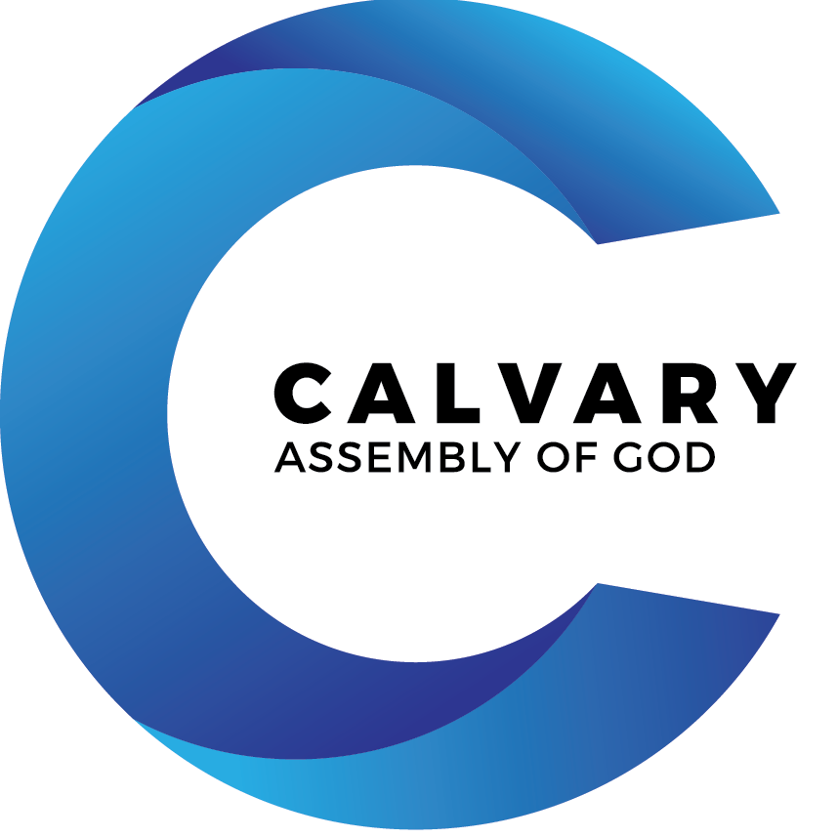

Water Baptism
Information Packet
Baptism: An Introduction

Many elements of Calvary Assembly exist so that no matter where you are on your spiritual journey, from just checking things out to being a Christ-follower for decades, you can participate as much as you choose to.

Yet there are certain things that the Bible itself tells us are for believers, people
who have made a commitment to following Christ as best as they can. One of
these is baptism. As Christ-followers, we are called by Jesus himself to be baptized,
as a public proclamation of this change in our lives … and in our eternities.

Still, baptism can be a touchy topic. Many of us were baptized as babies and
later confirmed as children. Shouldn’t that be enough?

Because of questions like that, we have created this Baptism Pack. In the pack,
you’ll find a list of frequently asked questions (FAQs) and a baptism registration
form. Please read the FAQ and if you still have more questions, feel free to call
the church office and speak to a pastor: (904) 272-5774

Baptism FAQs

What is the Meaning of Baptism?

It illustrates Christ’s death, burial, and resurrection.

“… Christ died for our sins … he was buried … and he rose again.” (1 Corinthians 15:3-4)

“For when you were baptized, you were buried with Christ, and in baptism you were also raised with Christ.” (Colossians 2:12)

It illustrates your new life as a Christian.

“When someone becomes a Christian, he becomes a brand new person inside. The old life has passed away and a new life has begun!” (2 Corinthians 5:17)

“By our baptism then, we were buried with him and shared his death, in order that, just as Christ was raised from the dead … so that we may live a new life!” (Romans 6:4).

Yet baptism doesn’t make you a Christian

Only your faith in Christ does that. Baptism is like a wedding ring; it’s the outward sign of the commitment you have made in your heart. (see Ephesians 2:8-9)

Who Should Be Baptized?

The Bible says that every person who believes in Christ should be baptized. A believer is someone who has realized that their sin has separated them from God. They have given up all personal efforts to reach God through good works or religious activity. They have concluded that Jesus Christ’s death on the cross for their sins is the only thing that can bridge the gap between themselves and God. A believer is someone who has decided to trust Christ alone for salvation. If you have come to that point in your spiritual journey, then you should be baptized. (see Acts 2:41; 8:12-13)

Why Should I Be Baptized?

First and foremost, it is to follow the example set by Jesus.

“At that time Jesus came from Nazareth and was baptized by John in the river.” (Mark 1:9).

In addition, Christ commanded it.

“Jesus said, ‘Go then, to all people everywhere and make them my disciples, baptize
them in the name of the Father, the Son, and the Holy Spirit, and then teach them to
obey everything that I have commanded you.’” (Matthew 28:19-20)

It demonstrates that you are a believer, a follower of Christ.

“We know that we have come to know Him, if we obey His commands,” (1 John 2:3).

When Should I Be Baptized?

As soon as you can after you become a believer

“Those who believed were baptized that day.” (Acts 2:41)

“Then Philip began with the Scripture and told him the good news about Jesus. As they
traveled along the road, they came to some water, and the man said, ‘Look, here is water. Why shouldn’t I be baptized right now?’ Philip said, ‘If you believe with all your heart, you may.’ The man answered, ‘I believe that Jesus Christ is the Son of God.’ So they went down into the water and Philip baptized him.” (Acts 8:35-38)

Yet it doesn’t have to occur the moment you believe

The Bible teaches that there is no reason to delay your baptism. After becoming a believer, you should participate in the next available opportunity your church provides for
baptism. If you wait until you feel you are a “good enough” believer, you will never feel ready for baptism.

Where is Calvary’s Baptism Held?

Throughout the year, Calvary Assembly regularly hosts baptism services in our sanctuary following the morning worship services. The service is intended to celebrate what God is doing in the lives of the individuals that are being baptized as well as the church as a whole.

Why is Immersion Baptism Important?

It is the method used in Jesus’ baptism

“As soon as Jesus was baptized, he went up out of the water.” (Matthew 3:16)

Every baptism mentioned in the Bible is by immersion.

“Then both Philip and the man went down into the water and Philip baptized him. When
they came up out of the water …” (Acts 8:38-39).

The word “baptize” means “to dip under water”

Immersion best symbolizes Christ’s burial and resurrection (see Romans 6:1-11).

The founders of the major denominations emphasized immersion.

Martin Luther, founder of the Lutheran denomination, said: “I would have those who are
to be baptized to be entirely immersed, as the word imports and the mystery signifies.”
John Calvin, founder of the Presbyterian denomination, said: “The word ‘baptize’ signifies to immerse. It is certain that immersion was the practice of the ancient church.”
John Wesley, the founder of the Methodist and Wesleyan denominations, said: “‘Buries
with Him’ alludes to baptizing by immersion according to the custom of the first church.”

What If I Was Baptized as an Infant?

In the Bible, we see parents bringing their children to Jesus. He held them and prayed for them and told us to welcome them. But he did not baptize them, and he did not tell anyone else to baptize them. If baptism signifies salvation (as the Bible teaches) then, only people who have intentionally received salvation should experience baptism. Thus, the Bible would indicate that baptism is for people who have made a decision to follow Christ.

If you have not experienced believer’s baptism, even though you have experienced baptism as an infant, the full meaning and significance of baptism has yet to take place in your life. We strongly encourage you to be baptized as an adult believer in Christ.

Some churches practice a “baptism of confirmation” for children. This is a time when parents pledge their commitment to raise their child according to Christian values and beliefs. While a very meaningful event, this is not Christian baptism; it is not mentioned in the Bible. Adult baptism doesn’t belittle your childhood baptism; it is a fulfillment of your parents’ hopes when they had you baptized.

Can Older Children Be Baptized?

All instances of baptism in the New Testament occur following an individual’s decision to trust Christ alone for salvation (see Acts 2:41; 8:12; 10:47-48). At Calvary Assembly of God, that means we wait to baptize until a child is old enough to believe and understand the true meaning of baptism. When a child makes a decision for Christ, we then joyously baptize them in the Christian faith after conferring with the parents.

What Should I Wear When I’m Baptized?

Dress in clothes you don’t mind getting wet. Women should wear thick shirts or a sweatshirt; men and women both should feel free to wear either shorts or jeans. There are changing rooms for both men and women at the facility. You will want to bring a towel and a change of clothes to wear home.

How Do I Register for Baptism?

To register for our next baptism service, simply complete the online registration form.

Part of the registration process involves writing a few paragraphs describing how and when you decided to trust Christ alone for your salvation (your personal testimony). This is a great reminder for you to celebrate the difference Christ has made in your life.

Baptism is the public profession of your faith in Christ. During the service we will read excerpts of your testimony. These testimonies play a significant and meaningful role in the service. Believers are encouraged, and seekers are challenged by the spiritual journey of others.

On the day of the baptism service, please arrive 20 minutes ahead of time for orientation. Bring a bathing suit, towel, shorts and/or shirt to wear over your suit.

